Mgt501 important solved subjective feb 2021
Complied by MEMON
1-How an organization implements successful Career Management Practices? 5 marks
Successful Career-Management Practices
Following steps can be helpful towards successful career management practices in the organizations.
• Placing clear expectations on employees.
• Giving employees the opportunity for transfer.
• Providing a clear succession plan
• Encouraging performance through rewards and recognition.
• Encouraging employees to continually assess their skills and career direction.
• Giving employees the time and resources they need to consider short- and long-term career goals

2-How would you differentiate downward communication from upward communication? 5 Marks.

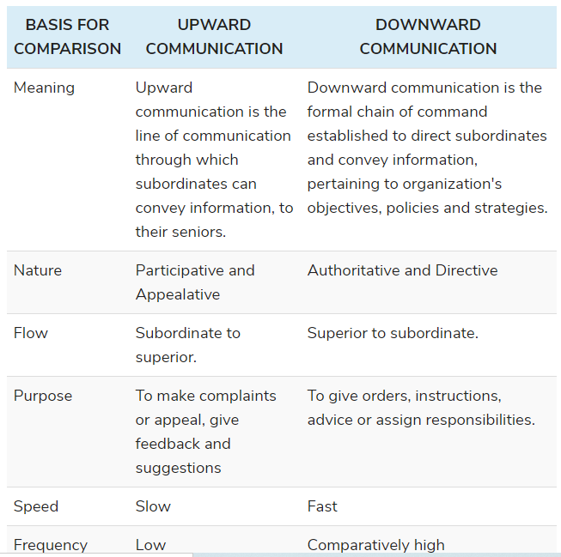
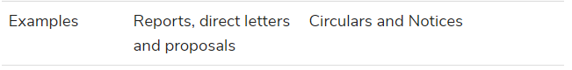

3- Describe the purpose of disability of employee benefits program. 3 marks
Disability Protection: Workers’ compensation protects employees from job-related accidents and illnesses. Some firms, however, provide additional protection that is more comprehensive. page:126
4-: Why customer appraisal is important in measuring the quality of a company’s products? 3 marks
Customer appraisal is why important to check quality of a product. 5 marks.

Customer Appraisal—The behavior of customers determines the degree of success a firm achieves. Therefore, some organizations believe it is important to obtain performance input from this critical source.
5- Briefly describe the interactionist view in Conflict Thought. 3 marks

interactionist view states that when conflict is based on issues rather than personalities, it can enhance problem solving and creativity. Open discussions of differing viewpoints allows for a thorough consideration of alternatives and their consequences in the course of decision making. Conflict can also increase motivation and energize people to focus on a task
6-. How organizations can prevent from corruption of power.
Organizations can prevent corruption of power by pushing for more contact between managers and employees; reducing employees' dependence on managers; and creating an open, performance-centered organizational culture and structure
7- Why incentive-plans do fails? Provide reasons.(5)
Poor perceived connection between performance and pay
Level of performance-based pay is too low
Lack of objective accountable results for most jobs, so performance appraisal ratings are used in place of objective outcomes
Faulty performance appraisal systems
Union resistance
Poor connection between Pay-For-Performance outcomes and corporate performance measures
8- What is transference (learning principle)? Describe three possible transfers training situations.(5)
Because the training occurs in a special environment, an important question to ask is whether learning will transfer to the actual job situation. Transfer of training occurs when trainees can apply the knowledge and skills learned in training course to their jobs. If the learning in one setting does not transfer to the actual job situation, the training has failed .
Three transfers training situations are possible
(1) Positive transfer of training, when the training activities enhance performance in the new situation; (2) negative transfer of training, when the training activities inhibit performance in new situation; and (3) no observable effect of training
🡺9- What benefit an organization can gain from safe and healthy employee. (5)
Benefits of a Safe and Healthy Workforce
• More productivity
• Increased efficiency and quality
• Reduced medical and insurance costs
• Lower workers’ compensation rates and payments
• Greater workforce flexibility
🡺10- One of your friend is suffering from high level of stress and he is not working well his work. What suggestions will you give to your friend in order to overcome his stress? (5)
one of your friend suffering from high level of stress and unable to perform his routine task.How would you advise him to overcome this problem(5)

Individual Stress Management _ Relaxation _ Time management _ Manage Change _ Get fit _ Let it go _ Social support _ Relaxation _ Physical Exercise
Dealing with Long-Term Stress _ Fatigue and exhaustion • Go to bed earlier • Take a good break (vacation) • Change work commitments if possible • Time management strategies

11-. Identify any 3 key consequences of behavior which either encourage or discourage people’s behavior in light of reinforcement theory.(3)
Four key consequences of behavior either encourage or discourage people’s behavior
- Positive Reinforcement-
- Negative Reinforcement-
- Punishment-
- Extinction
12- Which three key factors determine the like hood of stress?
Three key factors determine the likelihood of stress
◼ importance: How significant the event is to the person
◼ Uncertainty: Degree of clarity over what will happen
◼ Duration: Length of time the demands remain in place
🡺 14-360 degree method implementation ? 5 marks
360-Degree Feedback—Involves input from multiple levels within the firm and external sources as well, like superiors, self-rating, customers, subordinates, peers, outside observers.
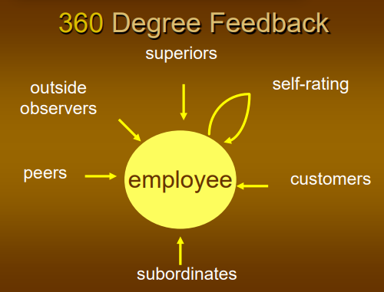
15- Which appraisal method is distortion? 5makrs
Performance appraisal rating errors are distortions in performance appraising ratings, whether positive or negative ,that reduce the accuracy of appraisals.
Lack of Objectivity
Halo Error
Leniency/Strictness
Central Tendency
Recent Behavior Bias
Personal Bias
Manipulating the Evaluation
16- Being HRM manager how will you make selection for international assignment? 5makrs
Selection of Employees for International Assignments
Emphasize cultural sensitivity as a selection criteria
Establish a selection board of expatriates
Require previous international experience
Explore the possibility of hiring foreign-born employees
Screen candidates’ spouses and families
17- Explain the role of Chief Executive Officer (CEO)(3)
A chief executive officer (CEO) is the highest-ranking executive in a company, whose primary responsibilities include making major corporate decisions, managing the overall operations and resources of a company, acting as the main point of communication between the board of directors (the board)
18-. What organization expect from HR professionals(5)
_ Understand problems assigned
_ Stay competent and professional through study and research
_ Maintain high standards of personal honesty and integrity
_ Consider the personal interests, welfare, and dignity of all employees affected by recommendations and actions
_ Ensure organizations maintain high regard for public interest and personal interests and dignity of employees
🡺19- Five possible ways of improvement of effectiveness of reward system.(5)
Improving Reward Effectiveness
Effectiveness of the rewards can be improved by considering the following factors.
• Link rewards to performance
• Ensure rewards are relevant
• Use team rewards for interdependent jobs
• Ensure rewards are valued
• Beware of unintended consequences
20- A manager rates all subordinates as ‘’3’’ at scale 1 to 5 which performance appraisal error done by manager? Reason?(5)
Central Tendency—Occurs when employees are incorrectly rated near the average or middle of the scale.
Central tendency is the inclination of managers to rate all their subordinates with an “average” score during performance appraisal. For instance, if the rating scale was from 1-7, the managers would leave out the extremes i.e. 1,2,6,7 and rate all the employees with a score between 3-5. This behaviour leads to the distortion of the purpose of evaluations as it does not reflect the employees’ true performance
Reason?
21- Why organization Measures the performance of employee(3)
It requires the manager to constantly check the performance in order to take corrective actions in case of deviations ensuring that such deviations do not occur gain. Thus the Performance measurement is an ongoing, continuous improvement operation.

22- Why organization offer vacation benefits to employee (3)
Better work-life balance.
Increased productivity.
Improved well-being.
🡺23- What are political Tactics. Difference between building relationship and controlling resources(5)
Political tactics are activities that fall outside the standardized, formal processes of the organization. Four types of political tactics are building relationships, controlling resources, image management, and blame and ingratiation.
Building Relationship
People develop relationships through coalitions, alliances, networks, and supportive managerial linkages. Coalitions are relationships formed over specific issues; alliances are general agreements of support among different individuals and groups; and networks are broad, loose support systems. Relationship building can either help or harm the organization.
Controlling Resources
Controlling resources and decisions, another type of political tactic, involves developing expertise, becoming indispensable, and influencing decision criteria. Like relationship building, controlling resources and decisions can either help or harm the organization.
🡺24-.Identify five methods usually used for career development(5)
Discussions with Knowledgeable Individuals
Company Material
Performance Appraisal System
Workshops
Personal Development Plans (PDP)
Software Packages
Career Planning Web Sites
25- How would you differentiate the multinational corporation from global corporation(3)
Multinational Corporation (MNC)—A firm that is based in one country (the parent or home country) and produces goods or provides services in one or more foreign countries (host countries).
Global Corporation—Has corporate units that are integrated to operate as one organization worldwide in a number of countries.
25- Differentiate career development from employee development?(3)
Employee development refers to an organization’s effort to develop it’s people for benefiting the business. Career development, on the other hand, refers to efforts by an employee to gain knowledge, skills and expertise to further their own career within or outside the organization they are currently associated with.

🡺26-. Briefly explain the statutory right of employees(3)
Statutory Rights are rights based on specific laws and statutes passed by federal, state, and local governments.
Statutory Rights of employees are as follows
-Protect from discrimination
-Safe working conditions
-Right to form unions
🡺27- What are the three factors McClelland identified in his theory of motivation?(3)
achievement, power, and affiliation.
🡺28-. Three key factor employee behavior
1-productivity
2-absenteeism
3-turnover.
Managers are particularly concerned with three types of employee behaviors: productivity, absenteeism, and turnover. A fourth type of behavior, organizational citizenship, is emerging as a vital concern.
29-Diffrence b/w leader and manager
Leaders • _ Innovate • _ Develop • _ Inspire • _ Take the long-term view• _ Ask what and why • _ Originate • _ Challenge the status quo. A LEADER is a • Visionary • Challenger • Inspirer • Developer Of People
Managers • _ Administer• _ Maintain • _ Control • _ Have a short-term view➔ Ask how and when ➔ Accept the status quo• A MANAGER is a _ Planner • _ Organizer • _ Coordinator • _ Performance Coach • _ Day-To-Day Problem Solver • _ Get The Work Of The Organization Done Through Others.
🡺30-Why International Assignments Fail ?
. Why an assignment get failure internationally.
_ Career blockage _ Culture shock _ Lack of pre-departure cross-cultural training _ Overemphasis on technical qualifications _ Family problems
🡺31-Stages of Career Development _
Stage 1: Preparation for Work (ages 0–25) _
Stage 2: Organizational Entry (ages 18–25) _
Stage 3: Early Career (ages 25–40) _
Stage 4: Mid-career (ages 40–55) _
Stage 5: Late Career (ages 55–retirement)
🡺32- Most of Labours are not wearing ear plugs during production in plant which them makes they habit.What will you suggest about it?
Positive Discipline Approach
1. Counseling 2. Written Documentation 3. Final Warning (decision day-off) 4. Discharge
33- Does indirect cost of an accident exceed the direct cost for an organization? Why or why not? 5 marks.

Indirect costs are almost always more expensive than direct costs because of the lasting impact they have on a company. It has been said that for every $1 of direct costs, there is an additional $4 in indirect costs. Accident investigation, productivity loss, and retraining take away valuable time and money away from an organization. It can often take several months to clear up a single workplace injury.
34- Suppose you're line manager How to protect environment via Safety and health 5
To Have A Healthy Work Environment
_ Fresh air _ Avoid suspect building materials _ Test new buildings _ Keep air ducts clean and dry _ Workers’ complaints _ Smoking free
35- The HRM Department and Training and Development
◼ Provide employee orientation training. ◼ Contribute to management development programs. ◼ Provide training and development. ◼ Evaluate training
36- What is straight pay and straight commission method used. Which is more appropriate?
. The straight salary approach is at one extreme in sales compensation. In this method, salespersons receive a fixed salary regardless of their sales levels. At the other extreme, the person whose pay is totally determined as a percentage of sales is on straight commission.
37- How will MBO be used for appraisal of employees
Management by objectives (MBO) is the appraisal method where managers and employees together identify, plan, organize, and communicate objectives to focus on during a specific appraisal period.

38-.how to prevent voilence in organization?

Violence Prevention Suggestions _
Develop a plan _
Review policies _
Treat with respect and dignity _
Problems occur _
Disciplined too harshly _
Laid off without reason _
Supervisor training _
Employee assistance programs _
Keep weapons out

39- Whistle blowing
Whistle blowing means employees can notify the wrong doings of the management. While federal employees who blow the whistle have certain legal protections; private-sector employees are far less protected. Because employees may decide to blow the whistle on an employer, many companies realize that it is in their best interest to establish a policy on whistle blowing.

